usually several underlying primary policies beneath the OPPI, frequently covering various design firms. In the event of a claim, all of the policies would respond for the various insureds. Each primary policy would involve different counsel (selected by that insurer) and potentially have different coverages. Defense of a claim in this scenario is less likely to be coordinated. A primary project specific policy coordinates the defense of all design team members with one counsel (subject to conflicts of interest) and one set of coverage terms. The risk management offering by many project-specific professional liability carriers may also assist with claims avoidance in a proactive way that an OPPI insurer could not provide.
IV. Group Captive Insurance: An Alternative Insurance Product That May Lead to
Reduced Operating Costs for Construction Firms

A. The Traditional Insurance Marketplace

Most businesses insure liability risks through traditional insurance products offered by domestic or international insurance companies. Common risks insured by businesses in the construction industry include:
• Property damage or bodily injury arising out of negligent operations (insured through commercial general liability);
• Personal and advertising injury arising out of negligent operations (insured through commercial general liability);
• Property damage or bodily injury due to operation of a motor vehicle (insured through business automobile liability); and
• Bodily injury and lost wages for injured employees as required to be paid by worker’s compensation statutes and the employer’s liability associated with employee injury (insured through worker’s compensation insurance).

Insurers of these coverages charge a premium based on an exposure base and a rate. For example, the premium for worker’s compensation insurance is calculated by determining payroll for a class of employees (i.e., construction superintendent, laborer, or consulting engineer) and applying a rate, which is publicly filed with state insurance departments for most insurers. Automobile liability premiums are based on a rate applied based on a combination of vehicle count, types and values of vehicles, number of employee drivers, and/or number of employee trips. Commercial general liability is typically based on an exposure specific to that insured, such as gross revenue, employee payroll, or square footage of premises. Underwriters arrive at final premium numbers after applying factors or credits that may increase or decrease premium. Poor loss history, for example, may increase the premium. For example, in the case of worker’s compensation, the Experience Modification Rating or EMR specifically adjusts premium based on past loss experience. Multiple lines and volume discounts, risk mitigation incentives, or exceptional loss experience may lead to positive credits that lower premiums. These particular lines of insurance are commonly subject to audit so the carriers can adjust premium throughout the year or after policy expiration to account for the actual risk exposure for the policy.
A traditional insurance company pools all of the risk transferred to it by underwriting policies. In the risk pool, there is a spectrum of profitability. Accounts with no or few losses in a year pay more premium than the insurers pay in claims, and the insurer makes a substantial profit from these insureds. Accounts with significant losses require the insurer to pay more in claims than it collects in premium, leading to negative cash flow. Many accounts are “average,” particularly over a three- to five-year period, meaning that the insurer pays less than it makes in premium but not by a large magnitude. The break-even point for insurers represents the point

when an insurer, after paying claims, covers its expenses and a moderate annual profit. The

chart at Appendix B illustrates the three categories of insureds.

Logically, the insureds with excellent loss experience (Group I as shown on Appendix B) subsidize the poor loss experience of Group III. Because the risk pools of all traditional insurers have some insureds that qualify as Group III, there is only so much an insurer will risk in terms of credits and premium reduction with its Group I insureds without jeopardizing the equilibrium to reach its break-even point. As a result, Group I insureds frequently pay more for insurance than may seem fair given that these insureds’ insurers pay very few claims on these insureds’ behalf.
Many businesses combat this reality by taking on substantial self-insured risk (“SIR”) for these lines of coverage in the form of a deductible or self-insured retention, which limits the exposure of insurers and demands a premium credit. These businesses are hoping that their favorable loss experience continues so they do not incur significant first-dollar payments on claims within the deductible or SIR. This reality means that businesses accepting higher deductibles and SIR must pay careful attention to risk management, contractual liability, and claims avoidance.
The rating systems of many insurers implement diminishing marginal returns on the acceptance of greater deductibles and SIRs at a certain level. Eventually, large businesses in Group I, even with significant self-insurance, face large traditional insurance premiums because of the risk pool and the implications of the chart at Appendix B. Group captive insurance was created to offer a reasonable and affordable insurance solution to these Group I businesses.

B. Overview of Group Captive Insurance

Group captive insurance refers to insurance provided by an insuring entity owned and operated by its members. Group captives may be homogenous, where all insureds are in the same class of business, or heterogeneous, where different businesses are involved (a construction contractor or engineering firm may be in small group with car dealerships, restaurant groups, staffing companies, and manufacturers). The structure of and premium for group captive insurance can be markedly different than traditional insurance, as described above. Several characteristics distinguish group captive insurance from traditional insurance:
• Members have greater input into the operations of the insurance company.
• Members select other insureds to admit into the captive membership thereby choosing their fellow members of the risk pool.
• Members earn a return on premium dollars, which are invested.
• Members can earn a dividend on premium dollars that are not spent on claims.
• Premiums are rated on individual member and group loss experience rather than just size and type of business.
Most group captives have stringent application criteria based primarily on business class, premium volume, and loss history. A typical group captive program will require $350,000 in premiums for CGL, WC, and AL plus a five-year loss ratio of less than twenty percent (20%).
The illustration at Appendix C shows the operation of a typical group captive policy. The captive portion of the policy is shown in blue and covers liability up to $400,000. The next
$600,000 of liability (for CGL and AL; unlimited exposure for WC) is covered by a reinsurer who also provides the fronting policy for the primary captive portion of the policy. Umbrella insurance can supply excess limits above what is offered within the captive.

The blue captive layer is further broken into two portions: the insured’s self insurance and the group’s risk sharing. For example, the first $100,000 may be the portion that the insured pays as self insurance. This portion is essentially a $100,000 deductible that is paid for out of the insured’s captive insurance premium. The next $100,000 to $400,000 is a tranche of liability that is covered by the entire group of captive members. For example, if the group captive has
200 members, then each member pays a 0.5% share of any members’ loss between $100,000 and $400,000 for a particular claim.

The group captive insurance premium is broken into three parts: the A Fund, the B Fund, and Expenses. The A Fund is the insured’s expected losses within the self insurance portion of the captive (in the example above, up to $100,000 per claim). The B Fund is the insured’s expected share of the group’s losses within the risk pool portion of the captive (in the example above, between $100,000 and $400,000 per claim). The Expenses portion of the premium covers reinsurance (above $400,000 in the example above), operating costs, state surcharges and fees, and broker fee.
The group captive insurance premium is typically lower, often substantially, than the cost of traditional insurance for CGL, WC, and AL. This is because the premium is based on actual loss experience and projected losses rather than the general rating scale of a traditional insurer, which accounts for the large risk pool and Group III insureds discussed above. The premium, however, has a variable component in that a bad loss experience in a given year can lead to an experience adjustment, capped at two times the A Fund portion of the premium. There is also a positive component to premium in the form of dividends if the insured’s loss experience is better than expected and risk sharing expenses allow for distribution of a dividend. Premiums grow before dividend payment through investment before dividends are eligible for distribution starting in year three.110
Group captive insurance has other benefits over traditional insurance offerings. The group captive manager will retain specialists in risk assessment and loss control, safety specialists, and claims handling specialists to serve the group captive members. The group captive will hold regular meetings throughout the year to address topics relevant to the group in avoiding claims and risk sharing. Many of these meetings have outstanding networking opportunities. In homogeneous captives, these meetings become de facto industry events. In heterogeneous captive, such meetings offer the chance to exchange best practices across industries and even business development potential. Since most group captives are based offshore, many meetings have the additional incentive of being located at tropical or resort locations outside of the United States.
C. Other Captive Insurance Options

The group captive insurance program described above is just one alternative insurance product that offers insureds options outside of the traditional marketplace for CGL, WC, and AL insurance. Similar self-insurance programs called 831(b) microcaptives are created for only one insured. The major difference between group captive insurance and 831(b) captives is that the latter option does not involve discrete risk-sharing within a pool or the reinsurance aspect of the group captive concept. Most 831(b) programs also lack the risk control, claims handling, and business networking opportunities presented by many group captive programs.
CONCLUSION

In today’s market, construction companies and owners of projects need to consider

carefully options available to insure against risks. Companies are ever-increasingly spending

Appendix B

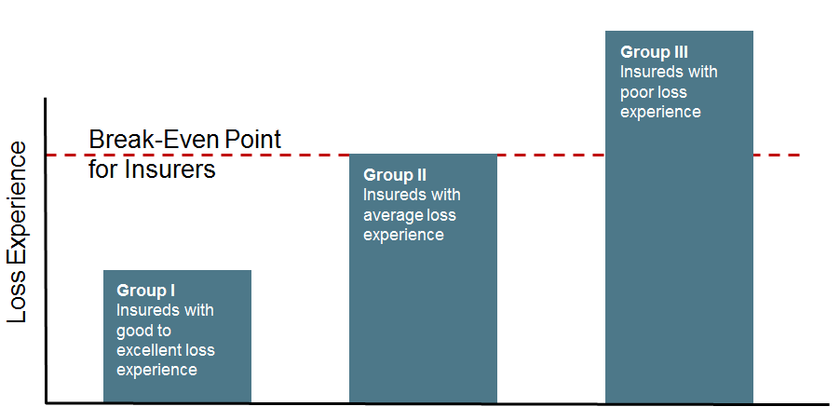

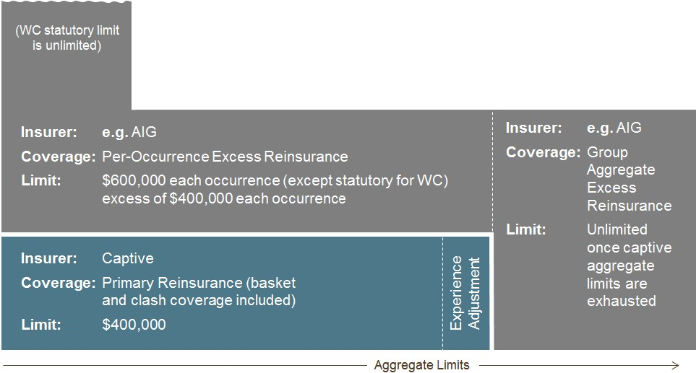Appendix C

Insurer: Vari es for each i nsured
Coverage: Umbrella (not part of capti ve) Limit: Vari es for each i nsured

2.E
::::i Q) (.)
c:
:; (.) (.)
0
..!.
Q)
c..

